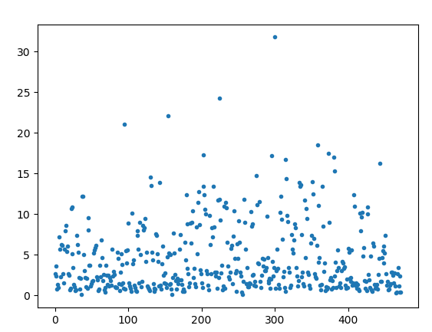

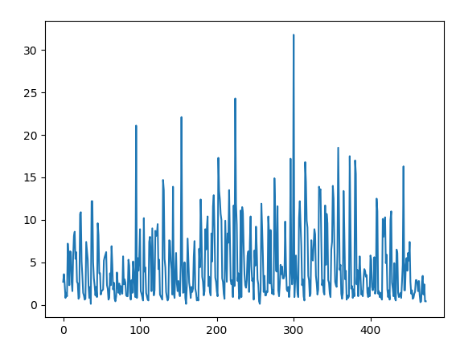

Imon -> median

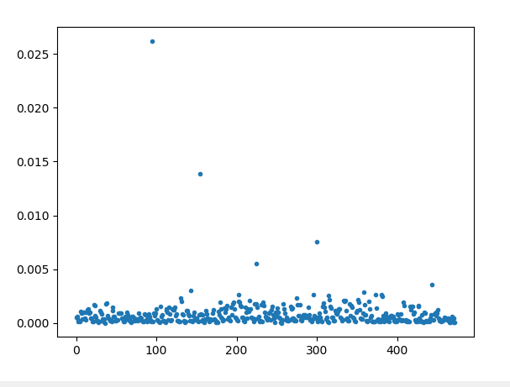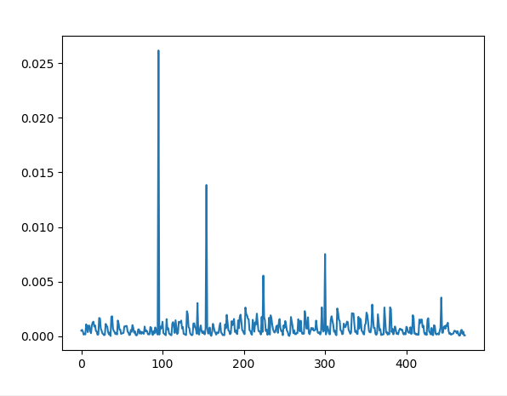

Imon/inst_lumi -> median

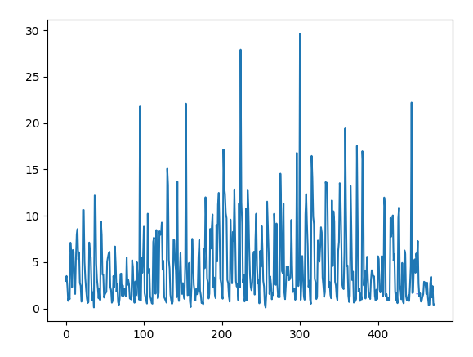

Imon 평균값들

['dpid_3042_2016.csv', 'dpid_3084_2016.csv', 'dpid_3113_2016.csv', 'dpid_3168_2016.csv', 'dpid_3190_2016.csv', 'dpid_3267_2016.csv', 'dpid_3271_2016.csv', 'dpid_340_2016.csv', 'dpid_392_2016.csv', 'dpid_409_2016.csv', 'dpid_417_2016.csv', 'dpid_418_2016.csv', 'dpid_6523_2016.csv'] -> Imon 평균이 15 이상인 것들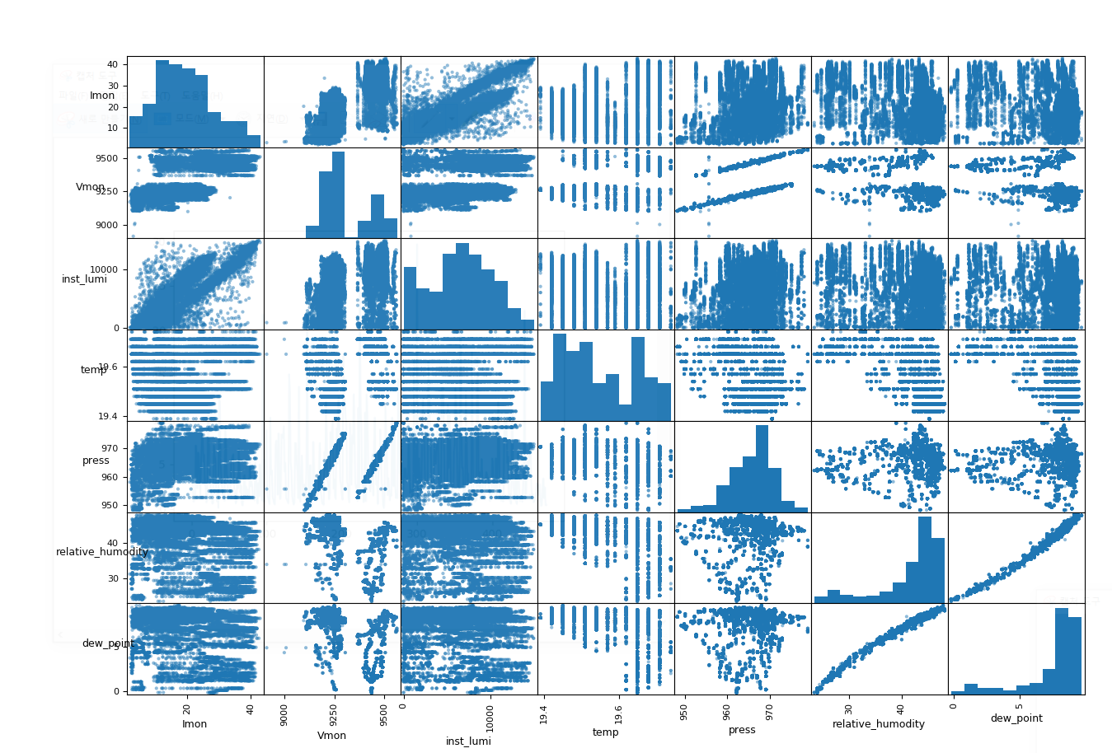

392

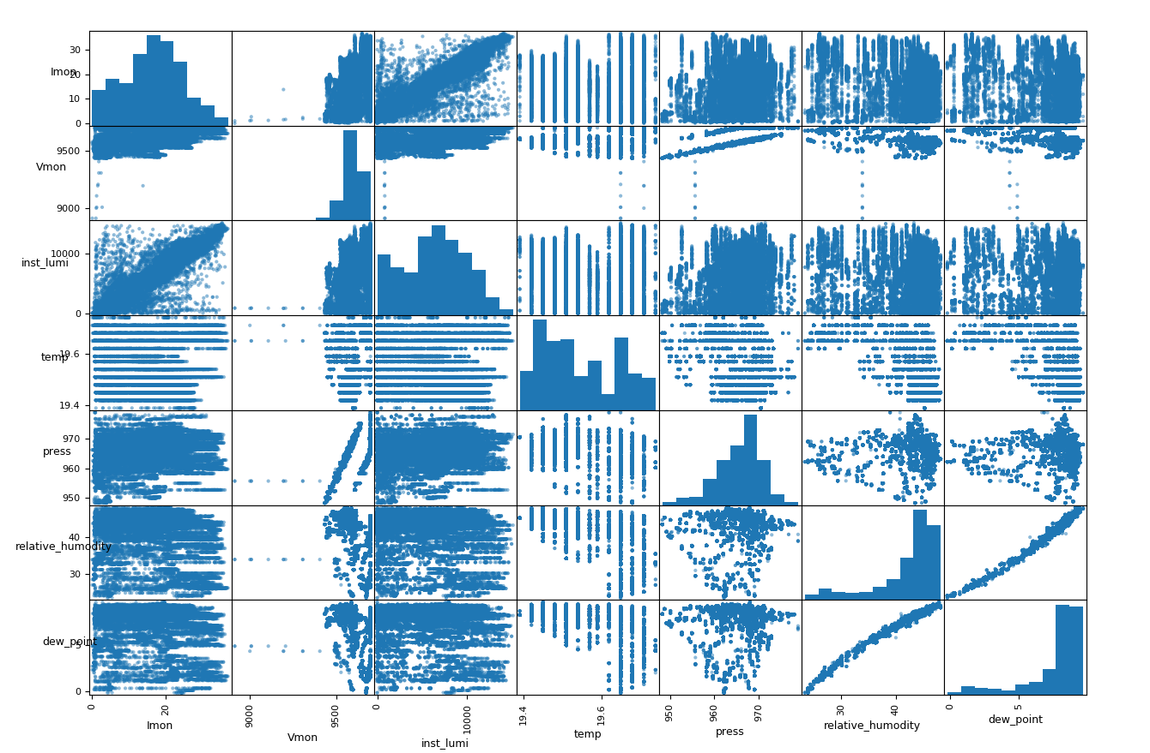

340

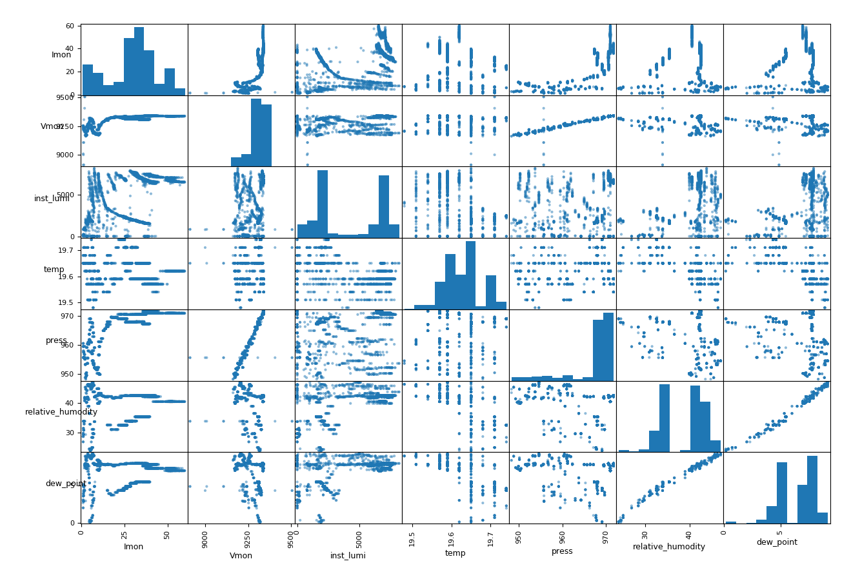

3271

1.4735e9를 기점으로 갈림.

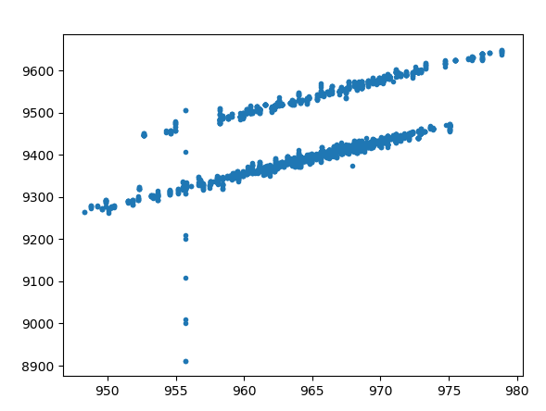1.4

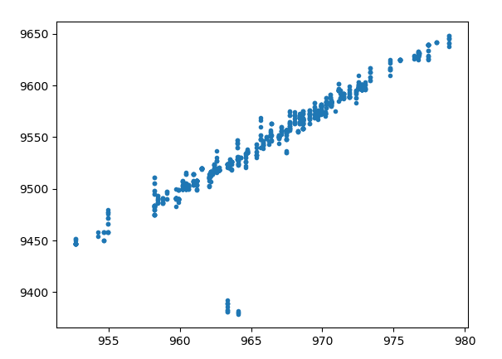1.4734

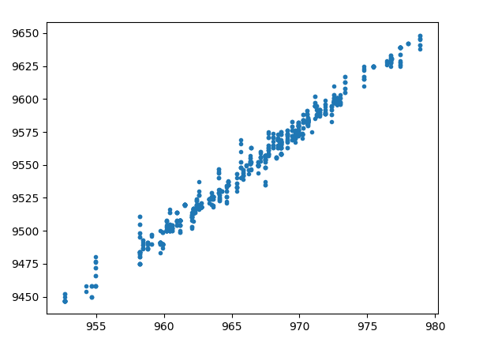1.4735

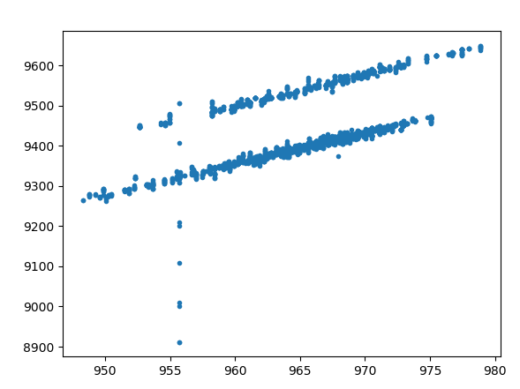1.4626

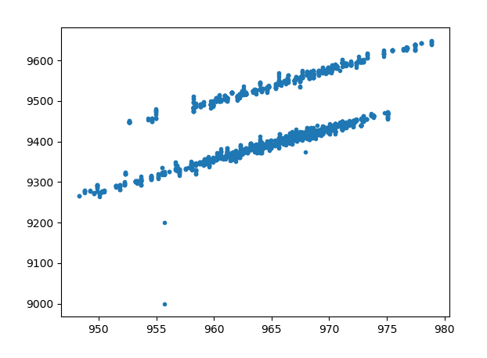1.4627

사진 120 dpid_2958_2016.csv

152 dpid_2999_2016.csv

189 dpid_3042_2016.csv

237 dpid_3099_2016.csv

248 dpid_3113_2016.csv

314 dpid_3190_2016.csv

350 dpid_3232_2016.csv

383 dpid_3271_2016.csv

404 dpid_6445_2016.csv

443 dpid_6523_2016.csv

2016.09.23 17:36:46 200V높임

2017 Vmon이 갈리지 않는데 Imon이 갈림

5 dpid320

210 dpid 3069

289 dpid 3167

366 dpid 3259

376 dpid 3271

386 dpid 6427

434 dpid 6523

435 dpid 6526

2018

5 dpid 320

125 dpid 2971

187 dpid 3046

205 dpid 3070

226 dpid 3099

254 dpid 3137

285 dpid 3176

330 dpid 3234

343 dpid 3249